No. of Pages | 3
No. of Questions | 4

Department of Computer Science and Engineering
MIDTERM EXAMINATION FALL 2010

CSE490/EEE453: LAN Switching and WAN Technologies
Total Marks: 60 Time Allowed: 70 minutes

- Answer ALL Four (4) questions.
- Figure in bracket [] next to each question indicates marks for that question.

Question No. 1

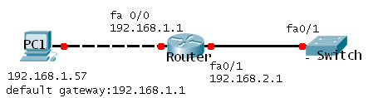
Figure No. 1
Switch(config)# interface vlan 1
Switch(config-if)# ip address 192.168.2.5 255.255.255.0
Switch(config-if)# no shutdown
Switch(config)#interface fa0/1
Switch(config-if)# switchport mode access
Switch(config-if)# switchport access vlan 1

- Refer to the figure no. 1 above. The switch VTY lines have been properly configured, but PC1 is unable to remotely manage the switch. How can this problem be resolved? What is this ‘interface vlan 1’? [3 marks]
- How does a layer 3 switch differ from a layer 2 switch? [3 marks]
- Differentiate between Fragment Free and Store & Forward switching methods. [3 marks]
- In a network DHCP is enabled for the PCs to get their IP configuration. But none of the PCs are unable to receive an IP configuration from the DHCP server, what can be the problem and provide a solution? [ 4 marks]
Switch(config)#line vty 0 15
Switch(config)# password cisco
Switch(config)# login

- What is the purpose of the above commands? [2 marks]

Question No. 2

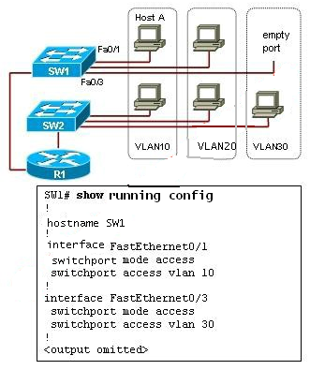
Figure No. 2
- Refer to the figure no. 2 above. What would happen if the network administrator moved the network cable of Host A from interface Fa0/1 to Fa0/3 on switch SW1? [3 marks]
- What are Static and Dynamic VLANs? [3 marks]
- What is the purpose of Dynamic Trunking Protocol? Two switches are connected. If both ends of the link are ports in dynamic auto mode, will the link be a trunk or not? [3 marks]

R(config)#interface f0/1.22
R(config-subif)#encapsulation dot1q 22
R(config-subif)#ip add 192.168.10.33 255.255.255.224
R(config-subif)#interface f0/1.33
R(config-subif)#encapsulation dot1q 33
R(config-subif)#ip add 192.168.10.65 255.255.255.224
R(config-subif)#interface f0/1.44
R(config-subif)#encapsulation dot1q 44
R(config-subif)#ip add 192.168.10.97 255.255.255.224
R(config-subif)# interface f0/1
R(config-if)#no shutdown

- The router receives two frames on physical interface f0/1. The destination IP address of the first frame is 192.168.10.130/27 and the 2nd frame is 192.168.10.127/27. What will the router do with these to frames? [4 marks]
- Do you need to configure a routing protocol on a router that is used for inter-VLAN routing? [2 marks]

Question No. 3

- What happens to the VTP configuration revision number of a switch if you change its VTP domain name? When are you required to do that? [3 marks]
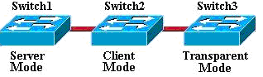
Figure No. 3
- Differentiate between Server mode of Switch 1 and Client mode of Switch2 shown in figure no. 3. [4 marks]
- If VTP is not working correctly, what should you check? List steps. [4 marks]
- A Server switch, ‘Switch 4’ with a higher configuration revision number than the Switch 1 and Switch 2 is added to the transparent switch, Switch 3 in figure no. 3. What is happen next? Mention the type of messages passed and which switch will update their information? [4 marks]

Question No. 4
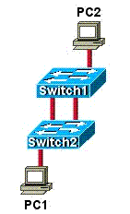
Figure No. 4
- Refer to the figure no. 4 above. PC1 a unicast frame to PC2. STP is not enabled, what will happen? [3 marks]
- If a switch has two ports with the same cost route to the root bridge, which of these ports will become the root port? [4 marks]
- If the default priority of a switch is 32768, why may the priority be shown as 32769? [2 marks]
- What are the five port states in the original STP? Which of these states are temporary and are not seen once the network has converged? [4 marks]
- Why might you use the command spanning-tree vlan 1 root secondary? [2 marks]

THE END

